Software Requirements Specification (SRS)

Hostel Management System
Version: 1.0
Date: July 13, 2025
Prepared by: Development Team
Document Status: Draft

Table of Contents
- Introduction
- Overall Description
- System Features
- External Interface Requirements
- System Requirements
- Non-Functional Requirements
- Other Requirements

1. Introduction

1.1 Purpose
This Software Requirements Specification (SRS) document describes the functional and non-functional requirements for the Hostel Management System (HMS), a web-based application designed to streamline hostel operations in educational institutions. The system aims to digitize and automate various hostel management processes including student information management, room allocation, complaint handling, notice distribution, stipend management, lost and found services, and visitor logging.

1.2 Document Scope
This document is intended for:
- Development teams responsible for system implementation
- Project managers overseeing the development process
- Quality assurance teams for testing requirements
- Stakeholders including hostel administration, university management, and end users
- System administrators responsible for deployment and maintenance

1.3 Intended Audience
The primary users of this system include:
- Students: Residing in the hostel who will use the system for room applications, complaints, notices, and other services
- Hostel Office Staff: Administrative personnel managing day-to-day hostel operations
- Provost: Senior administrator with approval authority for room allocations
- University Administration: Higher-level management requiring access to hostel data and reports
- Security Personnel: Staff managing visitor logs and hostel security

1.4 Product Overview
The Hostel Management System is a comprehensive web-based solution that centralizes hostel operations through a unified digital platform. The system facilitates efficient management of student records, room allocations, complaint resolution, communication through notices, financial transactions for stipends, lost item tracking, and visitor management. By providing role-based access and automated workflows, the system enhances operational efficiency while improving the overall hostel experience for students and staff.

1.5 Definitions, Acronyms, and Abbreviations
- HMS: Hostel Management System
- SRS: Software Requirements Specification
- UI: User Interface
- API: Application Programming Interface
- CRUD: Create, Read, Update, Delete operations
- Provost: Senior administrator responsible for hostel management
- Stipend: Financial assistance provided to eligible students
- Lost & Found: System for tracking lost and found items within the hostel

1.6 References
- IEEE Standard 830-1998 for Software Requirements Specifications
- University hostel management policies and procedures
- Existing manual processes and workflow documentation
- Security and privacy guidelines for educational institutions

2. Overall Description

2.1 Product Perspective
The Hostel Management System operates as a standalone web-based application that integrates with the university's existing infrastructure. The system is designed to replace manual processes currently used in hostel management and provides a centralized platform for all stakeholders. It interfaces with university databases for student verification and integrates with notification systems for real-time communication.

2.2 Product Functions
The system provides the following major functions:
- Comprehensive student information management with verification capabilities
- Dynamic room allocation and availability tracking
- Structured complaint management with status tracking and notifications
- Centralized notice board for institutional communication
- Financial stipend management with transaction recording
- Lost and found item tracking system
- Visitor registration and logging system with security features

2.3 User Classes and Characteristics
Students:
- Technical expertise: Basic to intermediate web application usage
- Primary activities: Room applications, complaint submissions, notice viewing
- Frequency of use: Daily to weekly access
- Critical requirements: Intuitive interface, quick access to personal information
Hostel Office Staff:
- Technical expertise: Intermediate computer skills
- Primary activities: Student management, complaint handling, notice posting
- Frequency of use: Daily intensive usage
- Critical requirements: Comprehensive dashboard, efficient workflow tools
Provost:
- Technical expertise: Basic to intermediate computer skills
- Primary activities: Approval workflows, oversight of hostel operations
- Frequency of use: Regular but not daily
- Critical requirements: Clear approval interfaces, summary reports
University Administration:
- Technical expertise: Basic computer skills
- Primary activities: Monitoring hostel capacity, generating reports
- Frequency of use: Periodic access for reporting
- Critical requirements: Comprehensive reporting, data export capabilities
Security Personnel:
- Technical expertise: Basic computer skills
- Primary activities: Visitor log monitoring, security management
- Frequency of use: Daily during duty hours
- Critical requirements: Simple interfaces, real-time visitor tracking

2.4 Operating Environment
- Platform: Web-based application accessible through modern browsers
- Client-side: HTML5, CSS3, JavaScript compatible browsers (Chrome, Firefox, Safari, Edge)
- Server-side: Linux/Windows server environment
- Database: Relational database management system (MySQL/PostgreSQL)
- Network: Intranet/Internet connectivity with secure HTTPS protocol
- Devices: Desktop computers, tablets, and mobile devices

2.5 Design and Implementation Constraints
- Must comply with university data privacy and security policies
- Should support concurrent access by multiple users
- Must be accessible on various devices and screen sizes
- Should integrate with existing university authentication systems
- Must maintain data integrity and provide audit trails
- Should support scalability for growing user base

2.6 Assumptions and Dependencies
- University provides reliable internet connectivity
- Users have basic computer literacy and web browser access
- University maintains up-to-date student database for verification
- Email/SMS infrastructure available for notifications
- Adequate server resources available for hosting
- Regular backup and maintenance procedures will be established

3. System Features

3.1 Student Information Management

3.1.1 Feature Description
The system manages comprehensive student information including personal details, academic information, and hostel-related data. It provides verification mechanisms to ensure only authorized students can access the system.

3.1.2 Functional Requirements
REQ-SIM-001: The system shall allow authorized staff to add new student records with the following mandatory fields:
- Full name (first, middle, last)
- Student ID (unique identifier)
- Academic level (undergraduate, graduate, etc.)
- Faculty/Department
- Contact information (phone, email, emergency contact)
- Academic year and semester
- Date of enrollment
REQ-SIM-002: The system shall verify student credentials against university database before allowing system access.
REQ-SIM-003: The system shall display current room allocation status for each student, including:
- Room number and type
- Bed assignment
- Allocation date
- Co-residents information
- Room facilities
REQ-SIM-004: The system shall allow students to update their contact information after verification.
REQ-SIM-005: The system shall maintain historical records of student room assignments and transfers.

3.2 Room Management

3.2.1 Feature Description
The room management system handles allocation, availability tracking, and application processes for hostel accommodation. It provides real-time visibility into room occupancy and manages the application approval workflow.

3.2.2 Functional Requirements
REQ-RM-001: The system shall display room-wise student allocation with the following information:
- Room number and capacity
- Current occupants with student details
- Available/occupied bed status
- Room facilities and amenities
- Floor and block information
REQ-RM-002: The system shall show available seats to different user types:
- Students: Available rooms in their eligible categories
- Hostel office: Complete availability overview
- University administration: Summary reports and statistics
REQ-RM-003: The system shall allow students to apply for available rooms with the following process:
- Browse available rooms by category/preferences
- Submit application with justification
- Track application status
- Receive notifications on application updates
REQ-RM-004: The system shall manage multiple applications for the same room:
- Queue applications chronologically
- Allow provost to review all applications
- Provide approval/rejection with comments
- Notify all applicants of final decision
REQ-RM-005: The system shall automatically update room availability upon allocation/deallocation.

3.3 Complaint Management System

3.3.1 Feature Description
A structured complaint handling system that allows students to report issues, tracks resolution progress, and ensures proper communication between students and hostel administration.

3.3.2 Functional Requirements
REQ-CMS-001: The system shall allow students to submit complaints with the following details:
- Complaint category (maintenance, facilities, security, etc.)
- Detailed description
- Priority level
- Location/room number if applicable
- Supporting attachments/images
- Expected resolution timeframe
REQ-CMS-002: The system shall automatically notify hostel office staff upon complaint submission.
REQ-CMS-003: The system shall track complaint status with the following states:
- Submitted
- Under review
- In progress
- Resolved
- Closed
REQ-CMS-004: The system shall allow hostel office staff to:
- View all complaints with filtering options
- Assign complaints to specific staff members
- Update complaint status and add progress notes
- Communicate with students regarding complaint resolution
REQ-CMS-005: The system shall notify students when their complaint status changes to "Resolved."

3.4 Notice Board System

3.4.1 Feature Description
A digital notice board system that facilitates communication from hostel administration to students through posted announcements and notifications.

3.4.2 Functional Requirements
REQ-NBS-001: The system shall allow hostel office staff and administrators to post notices with:
- Notice title and content
- Category/type classification
- Priority level (normal, important, urgent)
- Target audience (all students, specific blocks, etc.)
- Effective date and expiration date
- Attachment capabilities
REQ-NBS-002: The system shall automatically notify students of new notices through:
- In-system notifications
- Email notifications (if enabled)
- Dashboard alerts
REQ-NBS-003: The system shall display notices on student dashboard with:
- Chronological ordering
- Priority-based highlighting
- Read/unread status
- Archive functionality for older notices
REQ-NBS-004: The system shall allow notice management including:
- Edit/update posted notices
- Delete notices
- Archive expired notices
- Track notice readership statistics

3.5 Stipend Management

3.5.1 Feature Description
A financial management system for tracking and processing stipend payments to eligible students, maintaining transaction records and providing transparency in the stipend allocation process.

3.5.2 Functional Requirements
REQ-SM-001: The system shall allow hostel office to process stipend transfers with:
- Student selection from eligible list
- Stipend amount specification
- Payment method selection
- Transfer authorization
- Transaction reference generation
REQ-SM-002: The system shall maintain detailed stipend transaction records including:
- Student recipient information
- Transfer amount and date
- Payment method and reference
- Authorized staff member
- Transaction status
REQ-SM-003: The system shall provide stipend history for each student showing:
- All received stipends with dates
- Total amount received
- Average stipend amount
- Payment frequency
REQ-SM-004: The system shall generate stipend reports for administrative purposes:
- Monthly/quarterly stipend summaries
- Student-wise stipend allocation
- Budget utilization reports
- Audit trail documentation

3.6 Lost and Found System

3.6.1 Feature Description
A community-based system for reporting lost items and helping students recover lost belongings within the hostel premises.

3.6.2 Functional Requirements
REQ-LF-001: The system shall allow students to report lost items with:
- Item description and category
- Location where item was last seen
- Date and time of loss
- Contact information for recovery
- Item images if available
- Reward offer (optional)
REQ-LF-002: The system shall display lost item posts to all users with:
- Searchable item database
- Category-based filtering
- Date-based sorting
- Contact information for reporting finds
REQ-LF-003: The system shall notify the reporting student when:
- Someone reports finding their item
- Item is marked as found
- Item post is about to expire
REQ-LF-004: The system shall manage found item reports with:
- Matching with existing lost item posts
- Verification process for item recovery
- Status updates (lost, found, recovered)
- Automatic post expiration after specified period

3.7 Visitor Log System

3.7.1 Feature Description
A security-focused system for managing visitor registration, tracking, and monitoring to maintain hostel security and facilitate authorized visits.

3.7.2 Functional Requirements
REQ-VLS-001: The system shall allow students to pre-register visitors with:
- Visitor name and contact information
- Relationship to student
- Planned visit date and time
- Duration of visit
- Purpose of visit
- Required identification verification
REQ-VLS-002: The system shall provide daily visitor logs to security personnel showing:
- Scheduled visitors for the day
- Visitor check-in/check-out status
- Host student information
- Visit duration and purpose
- Security alerts for overdue visitors
REQ-VLS-003: The system shall allow security staff to:
- Verify visitor identity against pre-registration
- Record actual arrival and departure times
- Flag unauthorized or suspicious visitors
- Generate security incident reports
REQ-VLS-004: The system shall maintain visitor history including:
- Complete visit records per student
- Visitor frequency analysis
- Security incident tracking
- Audit trail for compliance purposes

4. External Interface Requirements

4.1 User Interfaces
The system shall provide responsive web interfaces optimized for:
- Desktop browsers (minimum 1024x768 resolution)
- Tablet devices (landscape and portrait orientations)
- Mobile devices (minimum 320px width)
- Accessibility compliance with WCAG 2.1 guidelines

4.2 Hardware Interfaces
- Standard web server hardware capable of handling concurrent users
- Database server with adequate storage and processing capacity
- Network infrastructure supporting HTTPS connections
- Backup storage systems for data protection

4.3 Software Interfaces
- Integration with university student information system
- Email server integration for notifications
- SMS gateway for critical alerts
- File storage system for document attachments
- Backup and recovery software integration

4.4 Communication Interfaces
- HTTPS protocol for secure data transmission
- RESTful API for potential mobile app integration
- Email protocols (SMTP) for notification delivery
- SMS gateway APIs for urgent communications

5. System Requirements

5.1 Functional Requirements Summary
The system shall support all features outlined in Section 3, providing comprehensive hostel management capabilities through an integrated web-based platform.

5.2 Database Requirements
- Relational database management system
- Data backup and recovery mechanisms
- Transaction logging for audit purposes
- Data encryption for sensitive information
- Regular database maintenance and optimization

5.3 Security Requirements
- User authentication and authorization
- Role-based access control
- Data encryption in transit and at rest
- Session management and timeout
- Audit logging for all system activities
- Protection against common web vulnerabilities

6. Non-Functional Requirements

6.1 Performance Requirements
- System response time: Maximum 3 seconds for standard operations
- Concurrent user support: Minimum 100 simultaneous users
- Database query optimization for large datasets
- Page load times: Maximum 5 seconds on standard internet connections

6.2 Reliability Requirements
- System uptime: 99.5% availability during operational hours
- Data backup frequency: Daily automated backups
- Disaster recovery: Maximum 24-hour recovery time
- Error handling: Graceful degradation for system failures

6.3 Usability Requirements
- Intuitive interface requiring minimal training
- Consistent navigation across all modules
- Clear error messages and user guidance
- Mobile-responsive design for all functionality

6.4 Scalability Requirements
- Architecture supporting increased user load
- Database scalability for growing data volumes
- Modular design allowing feature expansion
- Cloud deployment compatibility for future scaling

7. Other Requirements

7.1 Legal and Compliance Requirements
- Compliance with data protection regulations
- University policy adherence for student data
- Audit trail maintenance for financial transactions
- Privacy protection for personal information

7.2 Maintenance Requirements
- Regular system updates and patches
- Database maintenance and optimization
- User training and support documentation
- System monitoring and performance analysis

7.3 Documentation Requirements
- User manuals for all user types
- Technical documentation for system administrators
- API documentation for future integrations
- Training materials for staff and students
Document End
This SRS document serves as the foundation for the Hostel Management System development and should be reviewed and updated as requirements evolve during the development process.

Case diagram

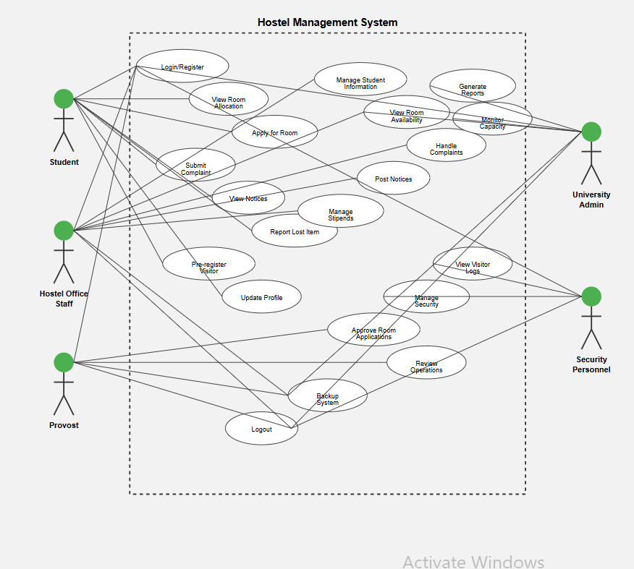

Activity diagram

